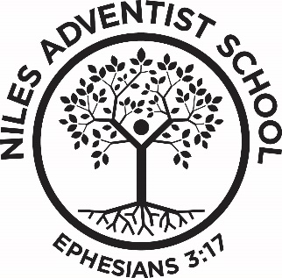

► Supper & Worship at Weko Beach: Weather and beach conditions permitting, Tonight, September 11, at 6 PM, NAS families are invited to bring your own picnic dinner to Weko Beach (5239 Lake Street, Bridgman, MI). Watermelon and drinks will be provided by the school!
► Upcoming Events:
- Fri. Sept 11, Lunch Orders Due
- Sept. 15, Tuition Payment #2 Due
- Sept. 15, Gift Card Orders Due
- Sept. 21-25, Standardized MAP Testing
- Sept. 24, School Picture Day. Remember to complete & return the yellow form. Everyone will have their picture taken for the yearbook, even if you don’t plan to order school pictures.

► Pay Tuition Online with Adventist School Pay: A link to Tuition Rates & Payments, is located at the top of our website. You may pay with your credit card or through electronic check. The electronic check fee (paid by the school) is lower than the credit card fee, so an electronic check is preferred.
► Dropping-Off & Picking up Students: Please enter the parking lot from Fairview Ave (dirt road east of the church and school). Please EXIT ONLY at the driveway west of the church during school hours. Safety is a priority at our school, and that also extends to the parking lot. We have some students who walk to/from school, and we need to keep traffic predictable. Also, the front of the school is for loading and unloading only. Please pull up as far as possible. If you are going to get out of your vehicle, please park your car in the parking lot. When parking, please pull all the way forward to reduce the need to back up in the parking lot. Please DO NOT block driveways on the dirt road while waiting in line.
► Scrip Shopping Card Orders: Buying shopping/gift cards for groceries, gas, restaurants, travel, etc. from NAS helps with tuition, and it helps the school through rebates from the retailers. We typically order gift cards twice a month. The next order date is September 17. eCards and reloading cards are always available. Order online (www.shopwithscrip.com, Code: AL8ELD988L1), in the office or contact Gina (call/text 269-845-8870 or gmeekma@gmail.com) or You can also sign up to pay online with PrestoPay or with a credit card. There is now an app to use to order gift cards—it's called RaiseRight by ShopWithScrip (www.raiseright.com).
► Special Order Shirts: Our first order for additional t-shirts or sweat shirts will be placed on September 25. Please have your orders to Crystal, in the office by September 24.
► Bible Study Classes: Contact pastor Darrel if you want to be part of bible studies via ZOOM or in person that will grow you to be a great disciple for Jesus and prepare you for baptism. 269-605-7895
► Lunch Orders: Lunch orders are due the Friday before. If they are turned in late your child may receive a different lunch than what is on the menu.

Monday: Ranch Wrap with Veggie Chicken Nuggets, Gogurt, Peaches, Crackers
Tuesday: Peanut Butter & Jelly Sandwich, Chips, Baby Carrots, Banana, Fruit Snacks
Wednesday: Pizza “Lunchables”, Granola Bar, Cherry Tomatoes, Pears
Thursday: Italian Subs, Pretzels, Celery with PB Dip, Raisins
Friday: Pasta Salad with Veggies and White Beans, Apple, Chocolate Chip Cookies

Happy Birthday!
Ava Sept-13

